**Problems**

**Chapter 1**

* 1. Derive the primary dimension for the MLT system of units for the following:

1. Specific weight
2. Power
3. Flow rate
4. Energy
   1. Show that the equation for the drag force given by



is dimensionally homogenous (i.e., the dimension on the left-hand side is the same as the dimension on the right-hand side)

* 1. Show that the following equations (a) Bernoulli equation and (b) normal stress in cylindrical coordinate systems, are dimensionally homogenous.



(b)



where s is stress, m is dynamic viscosity, v is velocity and r is radius.

* 1. If *l* is length, *V* is velocity and *n* is kinematic viscosity, which of the following combinations give dimensionless quantities?

1. 
2. 
3. 
4. 
   1. If a pressure loss in a pipe can be expressed by the equation given below, where *p* is pressure loss, *V* is velocity, *l* is pipe length and V is flow velocity. Determine the primary dimensions of the constant “*A*”?



* 1. Determine the dimensional and dimensionless and specific speed for a centrifugal pump with the following design point parameters.

Dimensional

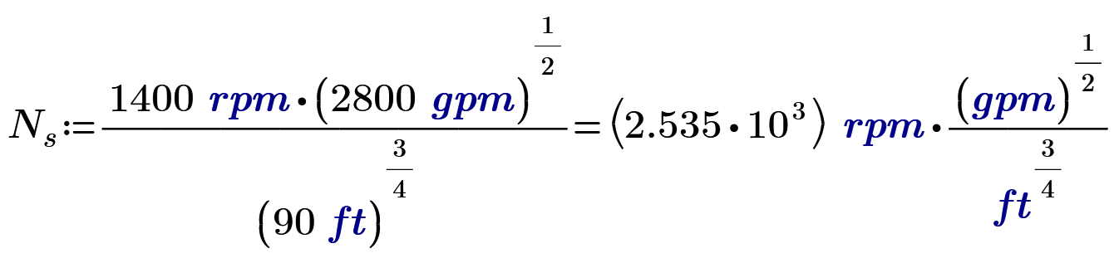

Dimensionless

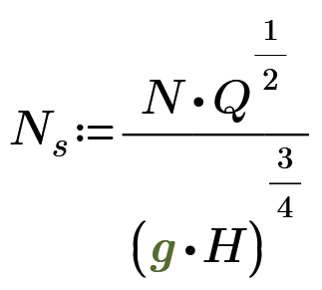

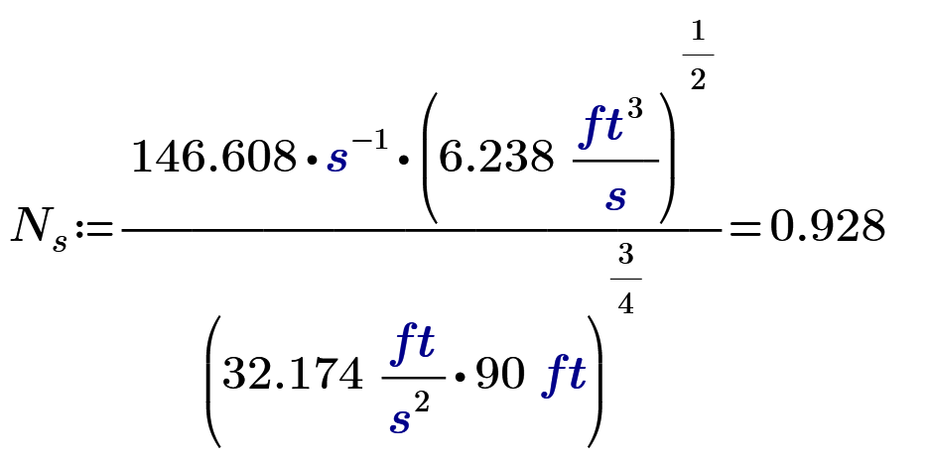

**Chapter 2**

**Problem 2. 1**