# Chapter 1 Analyzing Economic Problems

## Solutions to Review Questions

1. What is the difference between microeconomics and macroeconomics?

Microeconomics studies the economic behavior of individual economic decision makers, such as a consumer, a worker, a firm, or a manager. Macroeconomics studies how an entire national economy performs, examining such topics as the aggregate levels of income and employment, the levels of interest rates and prices, the rate of inflation, and the nature of business cycles.

2. Why is economics often described as the science of constrained choice?

While our wants for goods and services are unlimited, the resources necessary to produce those goods and services, such as labor, managerial talent, capital, and raw materials, are “scarce” because their supply is limited. This scarcity implies that we are constrained in the choices we can make about which goods and services to produce. Thus, economics is often described as the science of constrained choice.

3. How does the tool of constrained optimization help decision makers make choices? What roles do the objective function and constraints play in a model of constrained optimization?

Constrained optimization allows the decision maker to select the best (optimal) alternative while accounting for any possible limitations or restrictions on the choices. The objective function represents the relationship to be maximized or minimized. For example, a firm’s profit might be the objective function and all choices will be evaluated in the profit function to determine which yields the highest profit. The constraints place limitations on the choice the decision maker can select and defines the set of alternatives from which the best will be chosen.

**4.** **Suppose the market for wheat** is **competitive, with an upward-sloping supply curve, a downward-sloping demand curve, and an equilibrium price of $4.00 per bushel. Why would a higher price (e.g., $5.00 per bushel) not be an equilibrium price? Why would a lower price (e.g., $2.50 per bushel) not be an equilibrium price?**

If the price in the market was above the equilibrium price, consumers would be willing to purchase fewer units than suppliers would be willing to sell, creating an excess supply. As suppliers realize they are not selling the units they have made available, sellers will bid down the price to entice more consumers to purchase their goods or services. By definition, equilibrium is a state that will remain unchanged as long as exogenous factors remain unchanged. Since in this case suppliers will lower their price, this high price cannot be an equilibrium.

When the price is below the equilibrium price, consumers will demand more units than suppliers have made available. This excess demand will entice consumers to bid up the prices to purchase the limited units available. Since the price will change, it cannot be an equilibrium.

**5. What is the difference between an exogenous variable and an endogenous variable in an economic model? Would it ever be useful to construct a model that contained only exogenous variables (and no endogenous variables)?**

Exogenous variables are taken as given in an economic model, i.e., they are determined by some process outside the model, while endogenous variables are determined within the economic model being studied.

An economic model that contained no endogenous variables would not be very interesting. With no endogenous variables, nothing would be determined by the model so it would not serve much purpose.

6. Why do economists do comparative statics analysis? What role do endogenous variables and exogenous variables play in comparative statics analysis?

Comparative statics analyses are performed to determine how the levels of endogenous variables change as some exogenous variable is changed. This type of analysis is very important since in the real world the exogenous variables, such as weather, policy tools, etc. are always changing and it is useful to know how changes in these variables affect the levels of other, endogenous, variables. An example of comparative statics analysis would be asking the question: If extraordinarily low rainfall (an exogenous variable) causes a 30 percent reduction in corn supply, by how much will the market price for corn (an endogenous variable) increase?

**7. What is the difference between positive and normative analysis? Which of the following questions would entail positive analysis, and which normative analysis?**

**a) What effect will Internet auction companies have on the profits of local automobile dealerships?  
b) Should the government impose special taxes on sales of merchandise made over the Internet?**

Positive analysis attempts to explain how an economic system works or to predict how it will change over time by asking explanatory or predictive questions. Normative analysis focuses on what should be done by asking prescriptive questions.

a) Because this question asks whether dealership profits will go up or down (and by how much) – but refrains from inquiring as to whether this would be a good thing – it is an example of positive analysis.

b) On the other hand, this question asks whether it is desirable to impose taxes on Internet sales, so it is normative analysis. Notably, this question does not ask what the effect of such taxes would be.

## Solutions to Problems

1.1 Discuss the following statement: “Since supply and demand curves are always shifting, markets never actually reach an equilibrium. Therefore, the concept of equilibrium is useless.”

While the claim that markets never reach an equilibrium is probably debatable, even if markets do not ever reach equilibrium, the concept is still of central importance. The concept of equilibrium is important because it provides a simple way to predict how market prices and quantities will change as exogenous variables change. Thus, while we may never reach a particular equilibrium price, say because a supply or demand schedule shifts as the market moves toward equilibrium, we can predict with relative ease, for example, whether prices will be rising or falling when exogenous market factors change as we move toward equilibrium. As exogenous variables continue to change, we can continue to predict the direction of change for the endogenous variables, and this is not “useless.”

1.2 In an article entitled, “Corn Prices Surge on Export Demand, Crop Data,” the *Wall Street Journal* identified several exogenous shocks that pushed U.S. corn prices sharply higher. (See the article by Aaron Lucchetti, August 22, 1997, p. C17. on national income.) Suppose the U.S. market for corn is competitive, with an upward-sloping supply curve and a downward-sloping demand curve. For each of the following scenarios, illustrate graphically how the exogenous event described will contribute to a higher price of corn in the U.S. market.

**a) The U.S. Department of Agriculture announces that exports of corn to Taiwan and Japan were “surprisingly bullish,” around 30 percent higher than had been expected.**

**b) Some analysts project that the size of the U.S. corn crop will hit a six-year low because of dry weather.**

**c) The strengthening of El Niño, the meteorological trend that brings warmer weather to the western coast of South America, reduces corn production outside the United States, thereby increasing foreign countries’ dependence on the U.S. corn crop.**

a) Surprisingly high export sales mean that the demand for corn was higher than expected, at D2 rather than D1.

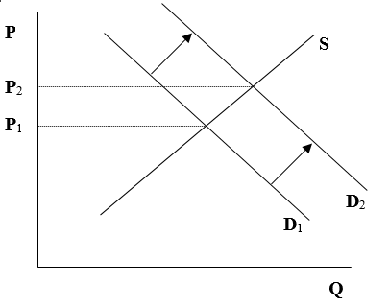

b) Dry weather would reduce the supply of corn, to S2 rather than S1.

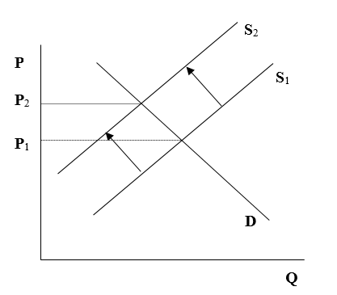

c) Assuming the U.S. does not import corn, reduced production outside the U.S. would not impact U.S. corn market supply. El Nino would, however, cause demand for U.S. corn to shift out, the figure being the same as in part (a) above.

1.3 In early 2008, the price of oil on the world market increased, hitting a peak of about $140 per barrel in July, 2008. In the second half of 2008, the price of oil declined, ending the year at just over $40 per barrel. Suppose that the global market for oil can be described by an upward-sloping supply curve and a downward-sloping demand curve. For each of the following scenarios, illustrate graphically how the exogenous event contributed to a rise or a decline in the price of oil in 2008:

a) A booming economy in China raised the global demand for oil to record levels in 2008.

b) As a result of the financial crisis of 2008, the U.S. and other developed economies plunged into a severe recession in the latter half of 2008.

c) Reduced sectarian violence in Iraq in 2008 enabled Iraq to increase its oil production capacity.

a) Booming economy in China shifts the demand curve for oil rightward (from D0 to D1 below), contributing to an increase in the price of oil.

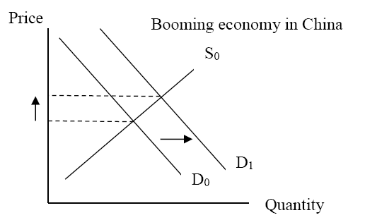

b) Recession in the U.S. and other developed economies shifts the demand curve for oil leftward (from D0 to D1 below), contributing to a decrease in the price of oil.

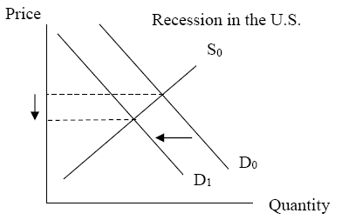

c) Increase in oil production capacity in Iraq shifts the supply for oil rightward (from S0 to S1 below), contributing to a decrease in the price of oil.

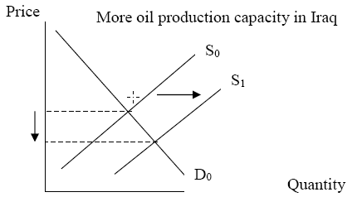

1.4 A firm produces cellular telephone service using equipment and labor. When it uses *E* machine-hours of equipment and hires *L* person-hours of labor, it can provide up to *Q* units of telephone service. The relationship between *Q*, *E*, and *L* is as follows: $Q=\sqrt{EL}$. The firm must always pay *PE* for each machine-hour of equipment it uses and *PL* for each person-hour of labor it hires. Suppose the production manager is told to produce *Q* = 200 units of telephone service and that she wants to choose *E* and *L* to minimize costs while achieving that production target.

a) What is the objective function for this problem?

b) What is the constraint?

c) Which of the variables (*Q*, *E*, *L*, *PE*, and *PL*) are exogenous? Which are endogenous? Explain.

d) Write a statement of the constrained optimization problem.

a) The production manager wants to minimize total costs *TC = PE*E + PL*L*.

b) The constraint is to produce *Q =* 200 units, so the manager must choose *E* and *L* so that $\sqrt{EL}=200$.

c) The endogenous variables are *E* and *L*, because those are the variables over which the production manager has control. By contrast, the exogenous variables are *Q*, *PE*, and *PL* because the production manager has no control over their values and must take them as given.

d) Student answers will vary.

1.5 The supply of aluminum in the United States depends on the price of aluminum and the average price of electricity (a critical input in the production of aluminum). Assume that an increase in the price of electricity shifts the supply curve for aluminum to the left (i.e., a higher average price of electricity decreases the supply of aluminum). The demand for aluminum in the United States depends on the price of aluminum and income shifts the demand curve for aluminum to the right (i.e., higher income increases the demand for aluminum). In 2004, national income in the United States increased, while the price of electricity fell, as compared to 2003. How would the equilibrium price of aluminum in 2004 compare to the equilibrium price in 2003? How would the equilibrium quantity in 2004 compare to the equilibrium quantity in 2003?

In 2003, the initial equilibrium is at price *P*1 and quantity *Q*1. As national income increased, demand for aluminum shifted to the right. The fall in the price of electricity shifted the supply curve to the right, from *S*1 to *S*2. Both shifts have the effect of increasing the equilibrium quantity, from *Q*1 to *Q*2. However, it is unclear whether price will rise or fall – if the demand shift dominates, price would rise; if the supply shift dominates, price would fall.

1.6 Ethanol (i.e., ethyl alcohol) is a colorless, flammable liquid that, when blended with gasoline, creates a motor fuel that can serve as an alternative to gasoline. The quantity of ethanol motor fuel that is demanded depends on the price of ethanol and the price of gasoline. Because ethanol fuel is a substitute for gasoline, an increase in the price of gasoline shifts the demand curve for ethanol rightward. The quantity of ethanol supplied depends on the price of ethanol and the price of corn (since the primary input used to produce ethanol in the U.S. is corn). An increase in the price of corn shifts the supply curve of ethanol leftward. In the first half of 2008, the price of gasoline in the U.S. increased significantly as compared to 2007, and the price of corn increased as well. How would the equilibrium price of ethanol motor fuel in the first half of 2008 compare to the price in 2007?

The increase in the price of gasoline shifted the demand curve for ethanol rightward (from D0 to D1), while the increase in the price of corn shifted the supply curve for ethanol leftward (from S0 to S1 below). Both changes had the impact of increasing the price of ethanol, moving the equilibrium from E0 in 2007 to E1 in 2008. (The impact of these changes on quantity is, in principle, ambiguous; the equilibrium quantity could either go up or down depending on the magnitude of the shifts in the demand and supply curves. The picture below shows the case in which there is a positive change in the equilibrium quantity.)

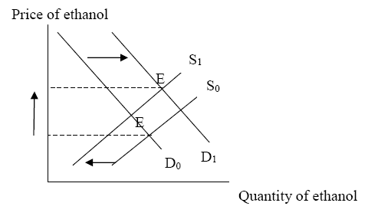

1.7 The price of gasoline in the United States depends on the supply of gasoline and the demand for gasoline. Gasoline is supplied by oil companies that sell it on several markets. Hence the supply of gasoline in the United States depends on the price of gasoline in the United States and its price on other markets. When the price of gasoline outside the United States increases, the U.S. supply decreases because firms prefer to sell the gasoline elsewhere. How would an increase in the price of gasoline abroad affect the equilibrium price of gasoline in the United States?

When the price of gasoline abroad goes up, the supply on the domestic market decreases. Firms are willing to supply less gasoline for the same price as before. At that price the domestic demand exceeds the supply and therefore the equilibrium price in the US has to increase. When this is followed by increase in the demand – consumers are willing to buy more gasoline then before – supply would again be smaller than the demand. Hence the equilibrium price of the gasoline would increase even more.

1.8 The demand for computer monitors is given by the equation *Qd* = 700 - *P*, while the supply is given by the equation *Qs* = 100 + *P*. In both equations *P* denotes the market price. Fill in the following table. For what price is the market in equilibrium—supply equals to the demand?

|  |  |  |  |  |  |
| --- | --- | --- | --- | --- | --- |
| ***P*** | **200** | **250** | **300** | **350** | **400** |
| ***Qd*** |  |  |  |  |  |
| ***Qs*** |  |  |  |  |  |

|  |  |  |  |  |  |
| --- | --- | --- | --- | --- | --- |
| *P* | 200 | 250 | 300 | 350 | 400 |
| *Qd* | 500 | 450 | 400 | 350 | 300 |
| *Qs* | 300 | 350 | 400 | 450 | 500 |

1.9 The demand for computer memory chips is given by the equation *Qd* = 500 – 2*P*, while the supply is given by the equation *Qs* = 50 + *P*. In both equations *P* denotes the market price. For what price is the market in equilibrium – supply equals demand? What is the equilibrium quantity?

|  |  |  |  |  |  |
| --- | --- | --- | --- | --- | --- |
| ***P*** | **50** | **100** | **150** | **200** | **250** |
| ***Qd*** |  |  |  |  |  |
| ***Qs*** |  |  |  |  |  |

As shown in the table below, the equilibrium price is 150, and the equilibrium quantity is 200.

|  |  |  |  |  |  |
| --- | --- | --- | --- | --- | --- |
| *P* | 50 | 100 | 150 | 200 | 250 |
| *Qd* | 400 | 300 | 200 | 100 | 0 |
| *Qs* | 100 | 150 | 200 | 250 | 300 |

1.10 The demand for sunglasses is given by equation *Qd* = 1000 - 4*P*, where *P* denotes the market price. The supply of sunglasses is given by equation *Qs* = 100 + 6*P*. Fill in the following table and find the equilibrium price.

|  |  |  |  |  |  |
| --- | --- | --- | --- | --- | --- |
| ***P*** | **80** | **90** | **100** | **110** | **120** |
| ***Qd*** |  |  |  |  |  |
| ***Qs*** |  |  |  |  |  |

|  |  |  |  |  |  |
| --- | --- | --- | --- | --- | --- |
| *P* | 80 | 90 | 100 | 110 | 120 |
| *Qd* | 680 | 640 | 600 | 560 | 520 |
| *Qs* | 580 | 640 | 700 | 760 | 820 |

1.11 This year’s summer is expected to be very sunny. Hence the demand for sunglasses increased and now is given by equation *Qd* = 1200 - 4*P*. How is the equilibrium price going to change compared with the scenario described in problem 1.7? Explain and then fill in the following table to verify your explanation.

|  |  |  |  |  |  |
| --- | --- | --- | --- | --- | --- |
| ***P*** | **80** | **90** | **100** | **110** | **120** |
| ***Qd*** |  |  |  |  |  |
| ***Qs*** |  |  |  |  |  |

When the demand increases, more people are willing to buy sunglasses at the equilibrium price. Hence, the supply is insufficient to satisfy the demand and the equilibrium price has to go up. The table below confirms this.

|  |  |  |  |  |  |
| --- | --- | --- | --- | --- | --- |
| *P* | 80 | 90 | 100 | 110 | **120** |
| *Qd* | 880 | 840 | 800 | 760 | **720** |
| ***Qs*** | **580** | **640** | **700** | **760** | **820** |

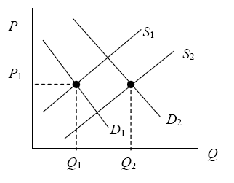

1.12 Suppose the supply curve for wool is given by *Qs* = *P*, where *Qs* is the quantity offered for sale when the price is *P*. Also suppose the demand curve for wool is given by *Qd*= 10 − *P* + *I* , where *Qd* is the quantity of wool demanded when the price is *P* and the level of income is *I*. Assume *I* is an exogenous variable.

a) Suppose the level of income is *I* = 20. Graph the supply and demand relationships, and indicate the equilibrium levels of price and quantity on your graph.

b) Explain why the market for wool would not be in equilibrium if the price of wool were 18.

c) Explain why the market for wool would not be in equilibrium if the price of wool were 14.

a) Assuming  we have  and . Graphing these yields:

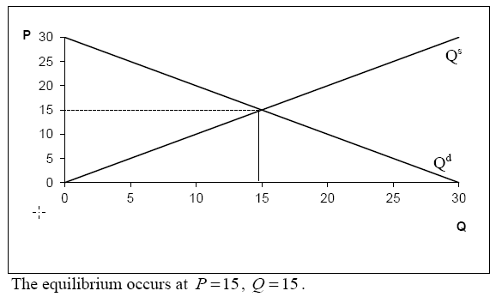

b) At a price of 18,  implying an excess supply of wool. Because sellers will not be able to sell all of their wool at this price, they will need to reduce price to attract buyers. At the lower price, the suppliers will offer a lower quantity of output for sale, and consumers will want to purchase more.

c) At a price of 14,, implying an excess demand for wool. Buyers will begin to bid up the price of wool until the new equilibrium is reached. At the higher price, the suppliers will offer a higher quantity of output for sale, and consumers will want to purchase less.

1.13 Consider the market for wool described by the supply and demand equations in Problem 1.12. Suppose income rises from *I*1 = 20 to *I*2 = 24.

a) Using comparative statics analysis, find the impact of the change in income on the equilibrium price of wool.

b) Using comparative statics analysis, find the impact of the change in income on the equilibrium quantity of wool.

With , we had  and , which implied an equilibrium price of 15.

With , we have  and . Finding the point where  yields:



Thus, a change in income of yields a change in price of .

b) Plugging the result from part a) into the equation for  reveals the new equilibrium quantity is . Thus, a change in income of yields a change in quantity of.

1.14 As commissioner of a league of recreational tennis players, you are responsible for purchasing court time from the local tennis facility. The members of the league will tell you how many hours of court time they would like for you to purchase each month. Your job is to find the least expensive way of buying the required amount of court time. After researching the options, you have found that the tennis facility offers three plans from which you can choose:

Plan A: Pay $15 per hour for court time at the facility, with no additional fees.

Plan B: Buy a Basic Membership to use the facility. Here you pay a membership fee of $100 per month, with an additional charge of $10 per hour of court time.

Plan C: Buy a Preferred Membership. This requires your league to pay a monthly fee of $250, with an additional charge of $5 for every hour of court time.

a) Which plan would you select if you are instructed to purchase 25 hours of court time at the lowest possible cost?

b) Which plan would you select if you are instructed to purchase 50 hours of court time at the lowest possible cost?

c) In this exercise is the number of hours of court time you purchase endogenous or exogenous? Explain.

d) In this exercise is the type of plan you purchase (A, B, or C) endogenous or exogenous? Explain.

e) Are your league’s total expenditures endogenous or exogenous? Explain.

a) Which plan would you select if you are instructed to purchase 25 hours of court time at the lowest possible cost?

Under Plan A, total expenditure = ($15/hour) x (25 hours/month) = $375 per month

Under Plan B, total expenditure = $100 + ($10/hour) x (25 hours/month) = $350 per month

Under Plan C, total expenditure = $250 + ($5/hour) x (25 hours/month) = $375 per month

Choose Plan B because monthly expenditures are lowest.

b) Which plan would you select if you are instructed to purchase 50 hours of court time at the lowest possible cost?

Under Plan A, total expenditure = ($15) x (50 hours/month) = $750 per month

Under Plan B, total expenditure = $100 + ($10/hour) x (50 hours/month) = $600 per month

Under Plan C, total expenditure = $250 + ($5/hour) x (50 hours/month) = $500 per month

Choose Plan C because monthly expenditures are lowest.

c) Since you are told how many hours to purchase, the number of hours is exogenous.

d) Since you get to choose the plan, the choice of plan is endogenous.

e) Since the expenditures are determined by the plan, and you get to choose the plan, the expenditures are endogenous.

1.15 Reconsider the problem of purchasing time on the tennis court in Problem 1.14. Suppose the members of your league give you a specified amount of money to spend on court time. They then want you to maximize the number of hours the league purchases with that budget. You can choose from the same three plans (A, B and C) available in Problem 1.14. As commissioner you are responsible for purchasing court time from the local tennis club. The members of the league will tell you how many hours of court time they would like for you to purchase each month. Your job is to find the least expensive plan to buy the required amount of court time.

a) Which plan would you select if you are instructed to purchase the largest number of hours while spending $300 per month?

b) Which plan would you select if you are instructed to purchase the largest number of hours while spending $900 per month?

c) In this exercise is the type of plan you purchase (A, B, or C) endogenous or exogenous? Explain.

d) In this exercise is the number of hours of court time you purchase endogenous or exogenous? Explain.

e) Are your league’s total expenditures endogenous or exogenous? Explain.

a) Which plan would you select if you are instructed to purchase the largest number of hours while spending $300 per month?

Let T be the number of hours you can purchase.

Under Plan A, total expenditure = $300 / month = ($15 $/hour) x (T hours) => T = 20 hours / month

Under Plan B, total expenditure = $300 / month = $100 + ($10 $/hour) x (T hours) => T = 20 hours / month

Under Plan C, total expenditure = $300 / month = $250 + ($5 $/hour) x (T hours) => T = 10 hours / month

Choose either Plan A or Plan B because you can purchase 20 hours with either, and you can purchase only 10 hours with Plan C.

b) Which plan would you select if you are instructed to purchase the largest number of hours while spending $900 per month?

Under Plan A, total expenditure = $900 / month = ($15 $/hour) x (T hours)

=> T = 60 hours / month

Under Plan B, total expenditure = $900 / month = $100 + ($10 $/hour) x (T hours)

=> T = 80 hours / month

Under Plan C, total expenditure = $900 / month = $250 + ($5 $/hour) x (T hours)

=> T = 130 hours / month

Choose either Plan C because you can purchase more hours than you can with either Plan A or Plan B.

c) Since you get to choose the plan, the choice of plan is endogenous.

d) Since the number of hours you can purchase depends on the plan, and the choice of plan is endogenous, the number of hours is endogenous.

e) Since the league tells you how much to spend, total expenditures are exogenous.

1.16 A major automobile manufacturer is considering how to allocate a $2 million advertising budget between two types of television programs: NFL football games and PGA tour professional golf tournaments. The following table shows the new sports utility vehicles (SUVs) that are sold when a given amount of money is spent on advertising during an NFL football game and a PGA tour golf event.



The manufacturer’s goal is to allocate its $2 million advertising budget to maximize the number of SUVs sold. Let *F* be the amount of money devoted to advertising on NFL football games, *G* the amount of money spent on advertising on PGA tour golf events, and *C*(*F*,*G*) the number of new vehicles sold.

a) What is the objective function for this problem?

b) What is the constraint?

c) Write a statement of the constrained optimization problem.

d) In light of the information in the table, how should the manufacturer allocate its advertising budget?

a) The objective function is the number of new SUVs sold, which we can denote by *Q*(*F, G*).

b) The constraint is that total spending must be less than or equal to $2million, or *TS * $2 million.

c) The constrained optimization problem is

$\max_{(F,G)}{Q(F,G)}$ subject to TS(F,G) ≤ $2 million

d) The following table shows all possible combinations of spending on football games and golf events:

|  |  |  |  |
| --- | --- | --- | --- |
| (*F, G*) | New sales from *F* | New sales from *G* | Total new sales |
| (0, 2) | 0 | 9 | 9 |
| (0.5, 1.5) | 10 | 8 | 18 |
| (1, 1) | 15 | 6 | 21 |
| (1.5, 0.5) | 19 | 8 | 27 |
| (2, 0) | 20 | 0 | 20 |

The table indicates that new SUV sales are maximized when (*F, G*) = (1.5, 0.5), that is, when the manufacturer spends $1.5 million on football and $0.5 million on golf.

1.17 An electricity producer has two power plants, each of which emits carbon dioxide (CO2), a greenhouse gas. Each plant is currently emitting 1,000,000 metric tons of CO2 per year. However, new emissions rules restrict the firm’s emissions to 1,000,000 metric tons of CO2 per year from both plants combined. The cost of operating a power plant goes up as it curtails its emissions. The table below shows the cost of operating each plant for different emissions levels:

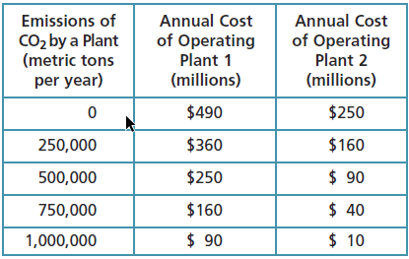

The firm’s goal is to choose emissions levels at each plant that minimize its total cost of operating its plants, subject to meeting its emissions target of 1,000,000 metric tons of CO2 per year from both plants combined. Let *X* denote the quantity of emissions from plant 1 and *Y* denote the quantity of emissions from plant 2. Let *TC*(*X*,*Y*) denote the total operating cost of the firm when the quantity of emissions from plant 1 is *X* and the quantity of emissions from plant 2 is *Y*.

a) What is the objective function for this problem?

b) What is the constraint?

c) Write a statement of the constrained optimization problem.

d) In light of the information in the table, what emissions levels from each plant should the firm choose?

a) The objective function is *TC*(*X*,*Y*).

b) The constraint is *X* + *Y* = 1,000,000

c) The statement of the problem is:

min(*X*,*Y*) *TC*(*X*,*Y*)

Subject to: *X* + *Y* = 1,000,000

d) The solution to the problem is: *X* = 750,000 and *Y* = 250,000. We can see this by creating a table that shows various combinations of *X* and *Y* that add up to 1,000,000 and computing the level of total operating cost associated with each feasible combination of emissions.

|  |  |  |  |  |  |
| --- | --- | --- | --- | --- | --- |
| Emissions in plant 1 | Total operating cost, plant 1 | Emissions in plant 2 | Total operating cost, plant 2 | Total emissions | Total operating cost, plants 1 and 2 combined |
| 0 | $490 | 1,000,000 | $10 | 1,000,000 | $500 |
| 250,000 | $360 | 750,000 | $40 | 1,000,000 | $400 |
| 500,000 | $250 | 500,000 | $90 | 1,000,000 | $340 |
| **750,000** | **$160** | **250,000** | **$160** | **1,000,000** | **$320** |
| 1,000,000 | $90 | 0 | $250 | 1,000,000 | $340 |

1.18 The demand curve for peaches is given by the equation *Qd* = 100 − 4*P*, where *P* is the price of peaches expressed in cents per pound and *Qd* is the quantity of peaches demanded (expressed in thousands of bushels per year). The supply curve for peaches is given by *Qs* = *RP*, where *R* is the amount of rainfall (inches per month during the growing season) and *Qs* is the quantity of peaches supplied (expressed in thousands of bushels per year). Let *P*\* denote the market equilibrium price and *Q*\* denote the market equilibrium quantity. Complete the following table showing how the equilibrium quantity and price vary with the amount of rainfall. Verify that when *R* = 1, the equilibrium price is 20 cents per pound and the equilibrium quantity is 20,000 bushels per year.

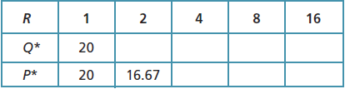

When *R =* 1, the equilibrium occurs where *Qd* = *Qs*, or 100 – 4*P* = P\**, or *P* =* 20. The equilibrium quantity can be found from either supply or demand; using the latter we have *Q*=*100 – 4(20) = 20. When *R =* 2, *Qd = Qs* implies 100 – 4*P\** = 2*P\** or *P\** = 16.67 and *Q\**= 33.33. Similarly, we can fill out the rest of the table:

|  |  |  |  |  |  |
| --- | --- | --- | --- | --- | --- |
| *R* | 1 | 2 | 4 | 8 | 16 |
| *Q\** | 20 | 33.33 | 50 | 66.67 | 80 |
| *P\** | 20 | 16.67 | 12.5 | 8.33 | 5 |

1.19 The world-wide demand curve for pistachios is given by *Qd* = 10 – *P*, where *P* is the price of pistachios in U.S. dollars, and *Qd* is the quantity in millions of kilograms per year. The world supply curve for pistachios is given by $Q^{s}=\frac{9P}{1+.05{\left(T-70\right)}^{2}}$, where *T* is the average temperature (measured in degrees Fahrenheit) in pistachio-growing regions such as Iran. The supply curve implies that as the temperature deviates from the ideal growing temperature of 70o, the quantity of pistachios supplied goes down. Let *P*\* denote the equilibrium price and *Q*\* denote the equilibrium quantity. Complete the following table showing how the equilibrium quantity and price vary with the average temperature. Verify that when *T* = 70, the equilibrium price is $1 per kilogram and the equilibrium quantity is 9 million kilograms per year.

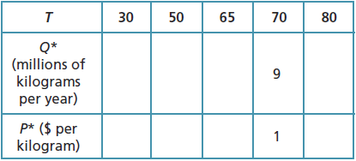

To fill in the table, one could create a set of tables, each corresponding to a particular level of T, that shows *Qd* and *Qs* for various prices, where *Qd* and *Qs* are computed using the formulas in the problem. Those tables are summarized below and then shown in detail.

|  |  |  |  |  |  |
| --- | --- | --- | --- | --- | --- |
| *T* | 30 | 50 | 65 | 70 | 80 |
| *Q*\*(millions of kilograms per year) | 1 | 3 | 8 | 9 | 6 |
| *P*\* ($ per kilogram) | 9 | 7 | 2 | 1 | 4 |

For each table, the equilibrium point is highlighted.

|  |  |  |
| --- | --- | --- |
|  | ***T* = 30** |  |
| *P* | *Qd* | *Qs* |
| 1 | 9.00 | 0.11 |
| 2 | 8.00 | 0.22 |
| 3 | 7.00 | 0.33 |
| 4 | 6.00 | 0.44 |
| 5 | 5.00 | 0.56 |
| 6 | 4.00 | 0.67 |
| 7 | 3.00 | 0.78 |
| 8 | 2.00 | 0.89 |
| 9 | 1.00 | 1.00 |
| 10 | 0.00 | 1.11 |

|  |  |  |
| --- | --- | --- |
|  | ***T* = 50** |  |
| *P* | *Qd* | *Qs* |
| 1 | 9.00 | 0.43 |
| 2 | 8.00 | 0.86 |
| 3 | 7.00 | 1.29 |
| 4 | 6.00 | 1.71 |
| 5 | 5.00 | 2.14 |
| 6 | 4.00 | 2.57 |
| 7 | 3.00 | 3.00 |
| 8 | 2.00 | 3.43 |
| 9 | 1.00 | 3.86 |
| 10 | 0.00 | 4.29 |

|  |  |  |
| --- | --- | --- |
|  | ***T = 65*** |  |
| *P* | *Qd* | *Qs* |
| 1 | 9.00 | 4.00 |
| 2 | 8.00 | 8.00 |
| 3 | 7.00 | 12.00 |
| 4 | 6.00 | 16.00 |
| 5 | 5.00 | 20.00 |
| 6 | 4.00 | 24.00 |
| 7 | 3.00 | 28.00 |
| 8 | 2.00 | 32.00 |
| 9 | 1.00 | 36.00 |
| 10 | 0.00 | 40.00 |

|  |  |  |
| --- | --- | --- |
|  | ***T = 70*** |  |
| *P* | *Qd* | *Qs* |
| 1 | 9.00 | 9.00 |
| 2 | 8.00 | 18.00 |
| 3 | 7.00 | 27.00 |
| 4 | 6.00 | 36.00 |
| 5 | 5.00 | 45.00 |
| 6 | 4.00 | 54.00 |
| 7 | 3.00 | 63.00 |
| 8 | 2.00 | 72.00 |
| 9 | 1.00 | 81.00 |
| 10 | 0.00 | 90.00 |

|  |  |  |
| --- | --- | --- |
|  | ***T = 80*** |  |
| *P* | *Qd* | *Qs* |
| 1 | 9.00 | 1.50 |
| 2 | 8.00 | 3.00 |
| 3 | 7.00 | 4.50 |
| 4 | 6.00 | 6.00 |
| 5 | 5.00 | 7.50 |
| 6 | 4.00 | 9.00 |
| 7 | 3.00 | 10.50 |
| 8 | 2.00 | 12.00 |
| 9 | 1.00 | 13.50 |
| 10 | 0.00 | 15.00 |

1.20 Consider the comparative statics of the farmer’s fencing problem in Learning-By-Doing Exercise 1.4, where *L* is the length of the pen, *W* is the width, and *A* = *LW* is the area.

a) Suppose the number of feet of fence given to the farmer was initially *F*1 = 200. Complete the following table. Verify that the optimal design of the fence (the one yielding the largest area with a perimeter of 200 feet) would be a square.

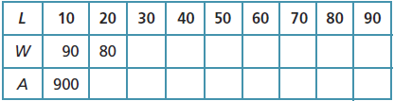

b) Now suppose the farmer is instead given 240 feet of fence (*F*2 = 240). Complete the following table. By how much would the length *L* of the optimally designed pen increase?

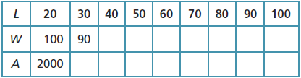

c) When the amount of fence is increased from 200 to 240 (*ΔF* = 40), what is the change in the optimal length (*ΔL*)?

d) When the amount of fence is increased from 200 to 240 (*ΔF* = 40), what is the change in the optimal area (*ΔA*)? Is the area *A* endogenous or exogenous in this example? Explain.

|  |  |  |  |  |  |  |  |  |  |
| --- | --- | --- | --- | --- | --- | --- | --- | --- | --- |
| L | 10 | 20 | 30 | 40 | 50 | 60 | 70 | 80 | 90 |
| W | 90 | 80 | 70 | 60 | 50 | 40 | 30 | 20 | 10 |
| A | 900 | 1600 | 2100 | 2400 | 2500 | 2400 | 2100 | 1600 | 900 |

b)

|  |  |  |  |  |  |  |  |  |  |
| --- | --- | --- | --- | --- | --- | --- | --- | --- | --- |
| L | 20 | 30 | 40 | 50 | 60 | 70 | 80 | 90 | 100 |
| W | 100 | 90 | 80 | 70 | 60 | 50 | 40 | 30 | 20 |
| A | 2000 | 2700 | 3200 | 3500 | 3600 | 3500 | 3200 | 2700 | 2000 |

The length L of the optimally designed fence increases by 10 ().

c) As in b), the length L of the optimally designed fence increases by 10 ().

d) When , . The area in this problem is an endogenous variable. The farmer may choose values for L and W and choices for these variables imply a value for A. So, implicitly, the farmer is choosing the area of the pen.

1.21 Which of the following statements suggest a positive analysis and which a normative analysis?

a) If the United States lifts the prohibition on imports of Cuban cigars, the price of cigars will fall.

b) A freeze in Florida will lead to an increase in the price of orange juice.

c) To provide revenues for public schools, taxes on alcohol, tobacco, and gambling casinos should be raised instead of increasing income taxes.

d) Telephone companies should be allowed to offer cable TV service as well as telephone service.

e) If telephone companies are allowed to offer cable TV service, the price of both types of service will fall.

f) Government subsidies to farmers are too high and should be phased out over the next decade.

g) If the tax on cigarettes is increased by 50 cents per pack, the equilibrium price of cigarettes will rise by 30 cents per pack.

a) Positive analysis – this statement indicates what the consequences of the U.S. action will be, ignoring any value judgment when making the claim.

b) Positive analysis – again this statement simply indicates the consequences of a change in an exogenous variable on the market, ignoring any value judgments.

c) Normative analysis – here the author implies that there are two possible solutions to providing additional revenues for public schools and suggests, based on a value judgment, which of the alternatives is better.

d) Normative analysis – again the author makes a claim based upon his own value judgment, namely that telephone companies offering cable TV service would be a good thing.

e) Positive analysis – The author is making a positive statement. The author is predicting the effect of a policy change on the price in a market.

f) Normative analysis – here the author is making a prescriptive statement about what should be done. This is a value judgment about the policy to subsidize farmers.

g) Positive analysis – the author is making a prediction about what will happen if the tax on cigarettes is increased. While the claim may not be accurate, the statement is predictive and made without the author imposing any value judgments on the prediction.